**Unlocking Insights Into The Global Air Transportation Network With Tableau**

Introduction:

Overview;

Gather relevant data related to global air transportation. This can include flight schedules, routes, airline information, passenger statistics, cargo data, and more. Ensure that the data is in a structured format, such as spreadsheets or databases..

Clean and prepare the data. This involves handling missing values, data transformation, and ensuring data quality. You may need to combine data from multiple sources into a single dataset.

Top of Form

**PURPOSE:**

Route Optimization: By analyzing historical flight data, airlines and aviation authorities can use Tableau to identify the most efficient flight routes, reducing fuel consumption and emissions, and potentially saving costs.

Flight Scheduling: Tableau can help in analyzing flight schedules to identify congestion points, delays, and potential improvements. This can lead to better on-time performance and passenger satisfaction.

3Safety Analysis: Safety is a paramount concern in the aviation industry. Tableau can be used to visualize safety-related data, including incident reports, maintenance records, and weather conditions to identify patterns and take preventive measures.

Demand Forecasting: Airlines can use Tableau to predict and visualize demand for different routes and timeframes. This information can be used for pricing strategies and capacity planning.

Airport Operations: Airports can benefit from using Tableau to monitor and optimize operations, including passenger flow, baggage handling, and ground services. It can also help identify peak travel times and adjust staffing accordingly.

Compliance and Regulations: Ensure that the aviation network complies with international and local regulations. Tableau can help in monitoring and reporting on compliance with safety standards and environmental regulations.

Customer Insights: Airlines can use Tableau to analyze customer data to understand passenger preferences, behaviors, and demographics. This can inform marketing campaigns, loyalty programs, and service improvements.

Cost Management: Visualizing cost data, such as fuel expenses, maintenance costs, and labor costs, can help airlines identify areas where cost reduction or optimization is possible.

Environmental Impact: With increasing emphasis on sustainability, Tableau can help airlines track and reduce their carbon footprint by visualizing emissions data and identifying ways to improve fuel efficiency.

Crisis Management: In times of crisis or disruptions (e.g., pandemics or extreme weather events), Tableau can help aviation authorities and airlines quickly assess the situation, plan responses, and communicate with the public.

Competitive Analysis: Airlines and airports can compare their performance to competitors, identifying strengths and weaknesses. This can inform strategic decisions.

Regulatory Reporting: Aviation agencies can use Tableau to streamline the process of generating and submitting required reports to regulatory authorities, reducing administrative burdens.

In summary, Tableau can be a powerful tool for visualizing and analyzing data in the global air transportation network. It can lead to improved safety, efficiency, and customer satisfaction while helping stakeholders make informed decisions based on data-driven insights.

|  |
| --- |
|  |

**PROBLEM STATEMENT & DESIGN THINKING**

**PROBLEM STATEMENT:** The global air transportation network involves a vast amount of data from various sources, such as airlines, airports, air traffic control, and weather data. The challenge is to integrate, clean, and structure this data for analysis within Tableau. Airlines need to optimize their routes for fuel efficiency, cost savings, and passenger convenience. Utilizing Tableau, we must identify patterns and opportunities to enhance route planning.For airlines, understanding passenger behavior and preferences is critical. Tableau can help analyze customer data to improve services and tailor marketing strategies. Monitoring safety and security in the air transportation network is paramount. Use Tableau to create real-time dashboards that can track incidents and alert relevant authorities. Air travel's environmental impact is a growing concern. Tableau can assist in analyzing data related to emissions, enabling airlines to adopt more sustainable practices.

Top of Form

Top of Form

**DESIGN THINKING**

1.Empathize:Understand the needs and pain points of various stakeholders in the air transportation network, such as airlines, airports, and passengers. Gather data on flight routes, schedules, delays, and passenger preferences to identify key challenges.

2.Define:Clearly define the problem and its scope. For example, the problem could be optimizing flight routes to reduce emissions or improving passenger experience at airports. Create personas representing different user groups, such as airline managers, air traffic controllers, and travelers.

3.Ideate:Brainstorm potential solutions to the defined problem. Explore innovative ways to visualize and analyze data related to the air transportation network using Tableau .Consider data sources, including real-time flight data, historical records, and passenger feedback.

4.Prototype:Develop Tableau dashboards and visualizations that can provide insights into the air transportation network. Create interactive maps, charts, and graphs to represent data on flight routes, delays, passenger volumes, and more. Design a user-friendly interface for stakeholders to interact with the data.

5.Test:Share the Tableau prototype with stakeholders, including airlines, airports, and regulatory authorities .Collect feedback and iterate on the visualizations and dashboards to ensure they address the needs and pain points identified in the empathize phase.

6.Implement:Deploy the finalized Tableau solution to relevant stakeholders .Train users on how to access and use the Tableau dashboards effectively .Establish processes for data updates and maintenance.

7.Evaluate:Continuously monitor the impact of the Tableau solution on the air transportation network .Collect data on the network's performance, such as improved route optimization, reduced delays, or enhanced passenger satisfaction. Make necessary adjustments to the Tableau dashboards and visualizations based on ongoing feedback and changing network conditions.

By applying design thinking principles and leveraging Tableau's data visualization capabilities, we can unlock valuable insights into the global air transportation network. This approach will enable better decision-making, optimization, and enhanced collaboration among stakeholders, ultimately leading to a more efficient and sustainable air transportation system.

**EMPATHY MAP:**

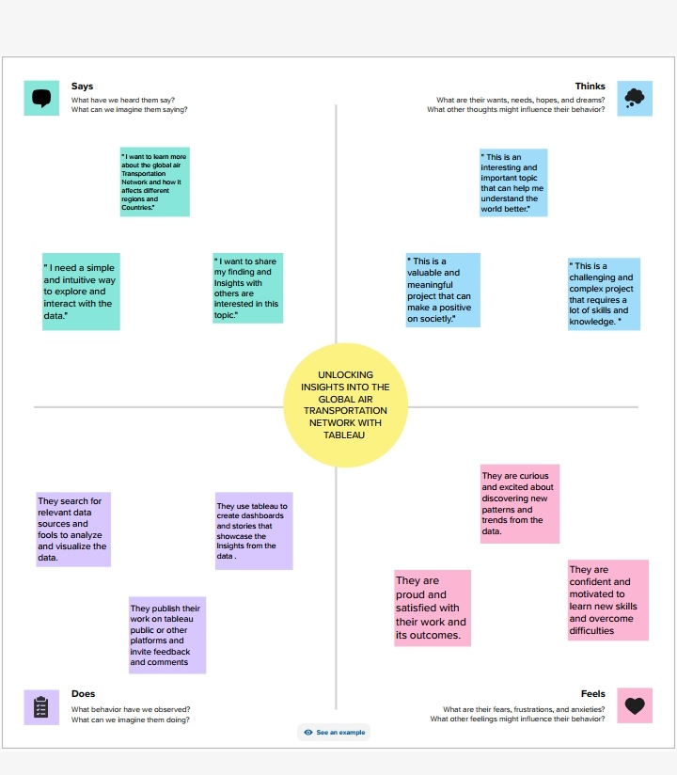

**BRAINSTORMING MAP;**

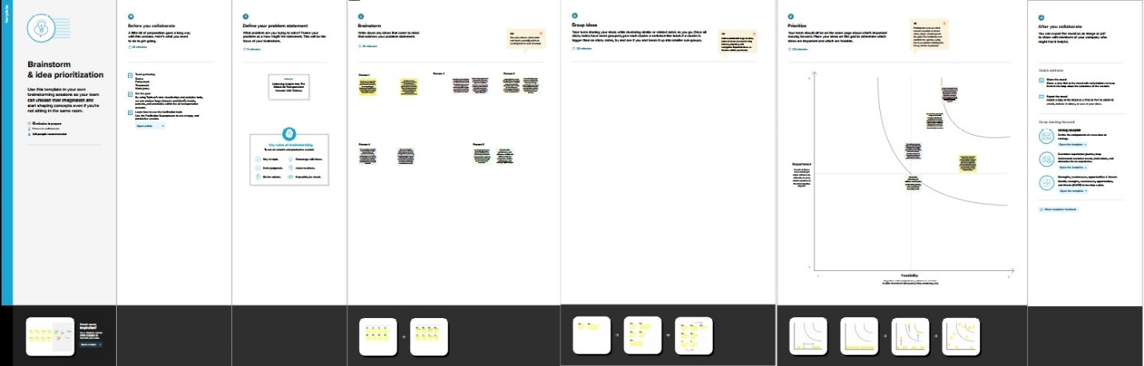

**Advantages:**

Data Visualization: Tableau is known for its powerful data visualization capabilities. It allows you to create interactive and dynamic visualizations that make it easy to explore complex data related to air transportation. These visualizations can help you identify trends, patterns, and anomalies in the data quickly.

Real-time Monitoring: Tableau can connect to real-time data sources, enabling you to monitor the global air transportation network in real-time. This is crucial for airlines and airport authorities to make quick decisions and respond to changing conditions, such as weather disruptions or airspace congestion.

Route Optimization: Airlines can use Tableau to analyze historical flight data and passenger demand to optimize routes, schedules, and capacity allocation. This can lead to more efficient operations and increased profitability.

Cost Reduction: By analyzing data on fuel consumption, maintenance, and other operational costs, airlines can identify areas for cost reduction. Tableau's data visualization tools can help stakeholders spot cost-saving opportunities.

Passenger Experience Improvement: Airports and airlines can use Tableau to analyze customer feedback and operational data to enhance the passenger experience. By identifying pain points and addressing them, they can improve customer satisfaction and loyalty.

Risk Management: Airlines can use Tableau to assess and mitigate risks related to safety, security, and regulatory compliance. Visualizing data on incidents and compliance can help stakeholders make informed decisions to minimize risks.

Market Analysis: Tableau can help airlines and other stakeholders analyze market trends, such as demand for specific routes, changes in customer preferences, and competitive dynamics. This can inform marketing and pricing strategies.

Regulatory Compliance: The aviation industry is subject to numerous regulations. Tableau can assist in monitoring and reporting on compliance with regulations, helping organizations avoid costly fines and penalties.

Data Integration: Tableau can integrate data from various sources, such as flight data, passenger data, and weather data, into a single platform. This integration enables a comprehensive view of the entire air transportation network.

Collaboration and Reporting: Tableau allows for easy sharing of insights and reports with stakeholders, such as airline executives, government agencies, and airport partners. This promotes collaboration and informed decision-making across the industry.

Scenario Planning: With Tableau, airlines and airport authorities can create scenarios and conduct "what-if" analyses. This can help them prepare for and respond to unexpected events or market changes effectively.

Environmental Sustainability: Airlines can use Tableau to track and report on their environmental impact, such as carbon emissions. This data can be used to develop and communicate sustainability initiatives.

**Disadvantages:**

|  |
| --- |
|  |

Data Limitations: Tableau's performance may be affected by large datasets, which are common in the global air transportation network. Handling vast amounts of data can lead to slower processing times and may require advanced hardware configurations.

Cost: Tableau can be expensive, especially if you require more advanced features or need to support a large number of users. Licensing costs, training, and maintenance expenses can add up.

Learning Curve: Tableau has a learning curve, particularly for those who are new to data visualization and analytics tools. Training and expertise are required to fully utilize its capabilities.

Limited Advanced Analytics: Tableau is primarily a data visualization tool, so its advanced analytics capabilities are somewhat limited compared to specialized analytics tools. Users may need to rely on additional software or integrate with other tools for more advanced modeling and forecasting.

Real-time Data Processing: Tableau is more geared toward batch processing and may not be the best choice for real-time data analytics, which is crucial in the dynamic world of air transportation.

Customization and Integration:

While Tableau offers a degree of customization, it may not be as flexible as some other tools when it comes to adapting to unique requirements or integrating with specific data sources or system.

Scalability: As your organization's data needs grow, scaling Tableau can become complex and costly. Ensuring it can handle increasing data volumes and user demands may require significant investment and planning.

Data Security and Compliance: Handling sensitive data in the global air transportation network, such as passenger information, cargo details, or operational data, comes with significant data security and compliance challenges. Ensuring data privacy and compliance with regulations can be a complex process.

Limited GIS Capabilities: While Tableau provides some Geographic Information System (GIS) capabilities, it may not be as powerful as dedicated GIS tools for in-depth spatial analysis. This can be a limitation when dealing with geographic aspects of air transportation.

Version Compatibility: Tableau users may encounter compatibility issues when working with different Tableau versions. It's essential to keep software up to date and ensure that your entire organization is using compatible versions.

Dashboard Design Complexity: Designing effective and user-friendly dashboards in Tableau can be challenging. Poorly designed dashboards may lead to confusion and misinterpretation of data.

**APPLICATIONS:**

Data Collection and Preparation :Gather relevant data: Collect data on airports, airlines, routes, passenger numbers, flight schedules, and other pertinent information. Various sources, such as aviation authorities, airlines, or open data platforms, can provide this data .Clean and structure the data: Ensure that your data is accurate, complete, and in a format that Tableau can work with. This may involve data cleaning, merging datasets, and creating calculated fields.

Data Connection: Import the cleaned data into Tableau. The software supports various data sources, including Excel, CSV, databases, and cloud platforms.

Data Exploration: Start by exploring your data within Tableau to understand its structure and identify key variables. Use drag-and-drop functionality to create basic visualizations like scatter plots, bar charts, and maps.

Create Relevant Visualizations: Design custom dashboards: Combine visualizations to create interactive dashboards that showcase different aspects of the global air transportation network.

Examples include: A world map showing airports and routes. A bar chart displaying the busiest airports or airlines .A line chart to visualize trends in passenger numbers. Heat maps for analyzing flight delays .Network diagrams to depict the connections between airports and airlines.

Add Interactivity :Utilize Tableau's interactive features to allow users to filter and drill down into data. This can include parameters, filters, and actions that make it easy for users to explore the data from different perspectives.

Annotations and Storytelling: Use text annotations and storytelling functionality to explain key insights and trends in your data. This helps in presenting your findings effectively to stakeholders.

Performance Optimization: Ensure your dashboards are optimized for performance, especially if you're dealing with large datasets. Tableau provides options to improve speed and responsiveness.

Sharing and Collaboration: Share your Tableau dashboards with stakeholders or the public through Tableau Server, Tableau Online, or by embedding them in a website. Collaborate with team members on data analysis.

Continuous Monitoring and Updating: Regularly update your data sources to keep your visualizations current. The aviation industry is dynamic, and changes occur frequently.

Advanced Analysis: Depending on your specific goals, you can use more advanced analytics within Tableau, including forecasting, clustering, and regression analysis, to gain deeper insights into the air transportation network.

Remember that the key to unlocking valuable insights in the global air transportation network with Tableau is combining your domain knowledge with the power of data visualization. By creating engaging and informative visualizations, you can make complex data more understandable and actionable for decision-makers in the aviation industry.

**CONCLUSION:**

Tableau provides a user-friendly interface for accessing and processing vast amounts of data related to air transportation. This accessibility allows researchers and stakeholders to explore various aspects of the network, including routes, carriers, passenger trends, and more. One of the most significant advantages of Tableau is its ability to create clear and intuitive visualizations. This can help in translating complex data into actionable insights. Maps, charts, and graphs can be used to represent data effectively, aiding decision-makers in understanding the dynamics of air transportation. The global air transportation network is dynamic and ever-changing. Tableau's capacity to work with real-time data enables stakeholders to track and respond to evolving trends and challenges in the industry promptly. Airlines and airports can utilize Tableau to optimize routes and scheduling based on historical data and current demand. This not only enhances operational efficiency but also reduces costs and environmental impact. Airlines and related businesses can use Tableau to gain a deeper understanding of passenger behaviors, preferences, and demographics. This information can guide marketing strategies, in-flight services, and overall customer experience. Monitoring the global air transportation network using Tableau can also enhance safety and security. By analyzing data related to incidents and anomalies, stakeholders can identify potential risks and develop proactive measures. Governments and policy-makers can use Tableau to assess the economic impact of the air transportation network, including job creation, tourism, and trade facilitation. This data can inform policies and investments in infrastructure and industry development. Tableau can help in evaluating the environmental impact of air transportation. By visualizing data on emissions, fuel consumption, and flight patterns, stakeholders can work towards more sustainable practices in the industry. Understanding the global air transportation network is crucial for maintaining global connectivity. This is especially important for international trade, humanitarian aid, and cultural exchange. Tableau can help ensure that connectivity remains robust and accessible. In conclusion, Tableau is a powerful tool for unlocking insights into the global air transportation network. Its ability to process and present data in a meaningful way can benefit airlines, airports, regulatory authorities, and various other stakeholders. The insights gained through Tableau can drive better decision-making, enhance operational efficiency, improve safety and security, and contribute to the sustainability and growth of this vital global industry.

**FUTURE SCOPE:**

Optimizing Operations: Airlines and airports can use Tableau to visualize real-time data on flight schedules, delays, and passenger loads. By identifying trends and patterns, they can make more informed decisions about scheduling, resource allocation, and maintenance, ultimately improving operational efficiency.

Customer Experience: Airlines can leverage Tableau to gain insights into customer behavior and preferences. They can use this information to tailor services, improve the passenger experience, and increase customer loyalty. Real-time dashboards can provide immediate feedback on in-flight services and customer satisfaction.

Route and Network Planning: Airlines can analyze historical data to identify profitable routes and optimize their network. Tableau can help them evaluate the impact of opening or closing routes, adjusting flight frequencies, and forming partnerships with other airlines.

Safety and Maintenance: By integrating data from various sensors and maintenance logs, airlines can predict and prevent equipment failures, reducing costly downtime. Tableau can be used to create visualizations that highlight potential maintenance issues and the overall safety of the fleet

.

Environmental Sustainability: Airlines are under increasing pressure to reduce their carbon footprint. Tableau can help them track and visualize their environmental impact, including fuel consumption, emissions, and sustainability initiatives. This data can be used to meet regulatory requirements and demonstrate a commitment to sustainability.

Supply Chain and Inventory Management: Airlines need to manage a complex supply chain for food, fuel, and other resources. Tableau can provide real-time visibility into inventory levels, helping airlines optimize their logistics and reduce waste.

Security and Risk Management: Airports and aviation authorities can use Tableau to monitor security systems, passenger flows, and other data sources to enhance security measures and respond to potential threats more effectively.

Market Analysis: Tableau can be used to analyze market trends, pricing strategies, and competitor performance. Airlines can make data-driven decisions about pricing, marketing, and expansion based on this information.

Government and Regulatory Compliance: Airlines and aviation authorities can use Tableau to ensure they meet regulatory requirements, monitor safety standards, and generate reports for government agencies.

Predictive Analytics: By leveraging machine learning and predictive analytics alongside Tableau, airlines can forecast demand, optimize pricing, and improve resource allocation.

Health and Crisis Management: In light of global health crises like pandemics, airlines can use Tableau to monitor and respond to health-related data in real-time, ensuring the safety of passengers and employees.

Global Connectivity: Airlines can use Tableau to analyze global connectivity and the impact of geopolitical events on their operations. This can help them make proactive decisions in response to changing global dynamics.

To make the most of Tableau for insights into the global air transportation network, organizations should invest in data integration, data quality, and data governance. Additionally, they should continually train their staff to develop data analytics and visualization skills, as well as stay up to date with the latest developments in Tableau and data technologies.

The future of unlocking insights in the aviation industry with Tableau is promising, with the potential to drive operational efficiencies, enhance customer experiences, and address critical challenges such as safety, sustainability, and market competitiveness

**RESULT:**

